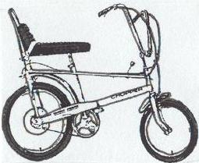
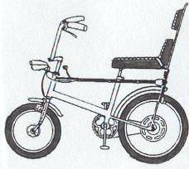

CHOPPER MKI (1970-72) CHOPPER HIGH BACKREST (1971)
Features: Adjustable handlebars, Barrel type Features: Adjustable handlebars, Barrel shape
Gear Konb. Gear Knob, Extra High Backrest and Pad.
Common Colours: Brilliant Orange, Horizon Common Colours: Targa Mustard
Blue, Gold Yellow, Flamboyant Green, Targa
Mustard.

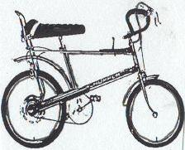
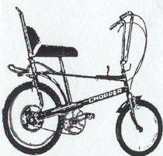

CHOPPER MKII (1972-80) CHOPPER SPRINT (1972-73)
Features: Fixed Handlebars, Carrier Rack, T-Bar Features: 16” frame, Drop Handlebars, Slimline
Sportshift. Wheels and tyres, Narrow Saddle.
Common Colours: Infra Red, Space Blue, Fizzy Common Colours: Flamboyant Green, Fire
Lemon, Quick Silver, Jet Black, Ultra Violet. Bronze.

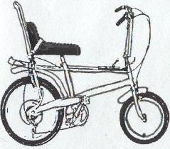
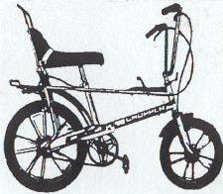

CHOPPER 5 (1973-76) CHOPPER SPECIAL EDITION (1976-77)
Features: 5 speed deraileur gear system. Features: Die cast alloy wheels, Rear internal
Common Colours: Sharp Pink Hub brake, Black and Chrome graphics.
Common colours: Silver.

Frame Number Location
If you have a MKI, High Backrest or an early MKII, the frame number will be located on the rear
Dropout LHS where the axle nut meets the frame, it will be a series of 7 numbers. If you have a
`73on MKII, Chopper 5 or Special Edition, the number is Located on the rear of the seat tube reading
vertically, It will be two letters followed by 7 numbers.

The

CHOPPER CLUB
The International Raleigh Chopper Owners Club

Founded January 1995

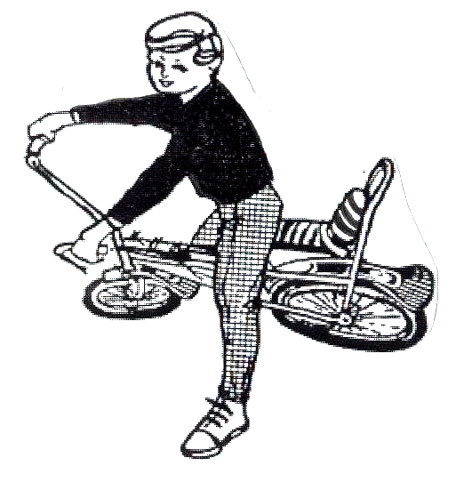

MEMBERSHIP APPLICATION FORM

The club was formed by Chopper Enthusiasts Andy Forey and Matthew peace In 1995 as
a result of the growing interest in the marque. It was formed to promote the interest in the
chopper, and to help the exchange of information on Chopper bicycles

